Insert your centre number, name and candidate number into the header above.
Save this evidence document as evidence_ followed by your centre number_ candidate number. For example: evidence_ zz999_9999
Screenshots or program listings must be copied into appropriate cells in the following table.
Examiners must be able to read the contents including any screenshots without the use of a magnifying glass. Answers that are not readable or missing will not be awarded any marks.
Save this evidence document at regular intervals, for example every 10 minutes.
Question 1
Part 1(a)
{Copy and paste the program code listing for Question 1(a) here}

# main
StackData=[-1 for _ in range(10)]
StackPointer=0

Part 1(b)
{Copy and paste the program code listing for Question 1(b) here}

def OutputStack():
global StackPointer
for item in StackData:
print(item)
print(StackPointer)

Part 1(c)
{Copy and paste the program code listing for Question 1(c) here}

def Push(num):
global StackPointer
if StackPointer == len(StackData):
return False
StackData[StackPointer]=num
StackPointer+=1
return True

Part 1(d)(i)
{Copy and paste the program code listing for Question 1(d)(i) here}

# main
StackData=[-1 for _ in range(10)]
StackPointer=0
for i in range(11):
if Push(int(input("Input a number to add onto the stack. "))): print("Successfully added.")
else: print("Stack full.")
print(StackData)

Part 1(d)(ii)
{Copy and paste the screenshot for Question 1(d)(ii) here}

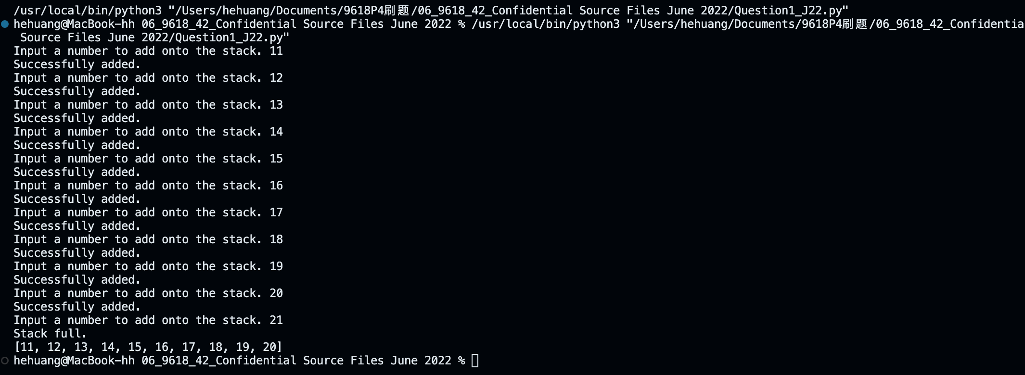

Part 1(e)(i)
{Copy and paste the program code listing for Question 1(e)(i) here}

def Pop():
global StackPointer
if StackPointer==0: return -1

num=StackData[StackPointer-1]
StackData[StackPointer-1]= -1
StackPointer-=1
return num

Part 1(e)(ii)
{Copy and paste the screenshot for Question 1(e)(ii) here}

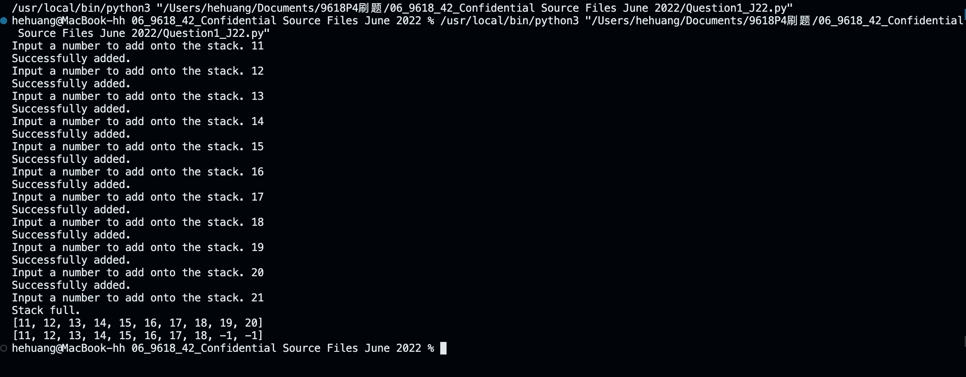

Question 2
Part 2(a)
{Copy and paste the program code listing for Question 2(a) here}
import random

# main
ArrayData=[[random.randint(1,100)for _ in range(10)] for _ in range(10)]

Part 2(b)(i)
{Copy and paste the program code listing for Question 2(b)(i) here}

import random

# main
ArrayData=[[random.randint(1,100)for _ in range(10)] for _ in range(10)]

ArrayLength=10
for x in range(0,ArrayLength):
for y in range(0,ArrayLength-1):
for z in range(0,ArrayLength-y-1):
if ArrayData[x][z]>ArrayData[x][z+1]:
TempValue=ArrayData[x][z]
ArrayData[x][z]=ArrayData[x][z+1]
ArrayData[x][z+1]=TempValue

Part 2(b)(ii)
{Copy and paste the program code listing for Question 2(b)(ii) here}

def Output():
for row in ArrayData:
temp=""
for co in row:
temp+=str(co)+' '
print(temp)

Part 2(b)(iii)
{Copy and paste the screenshot for Question 2(b)(iii) here}

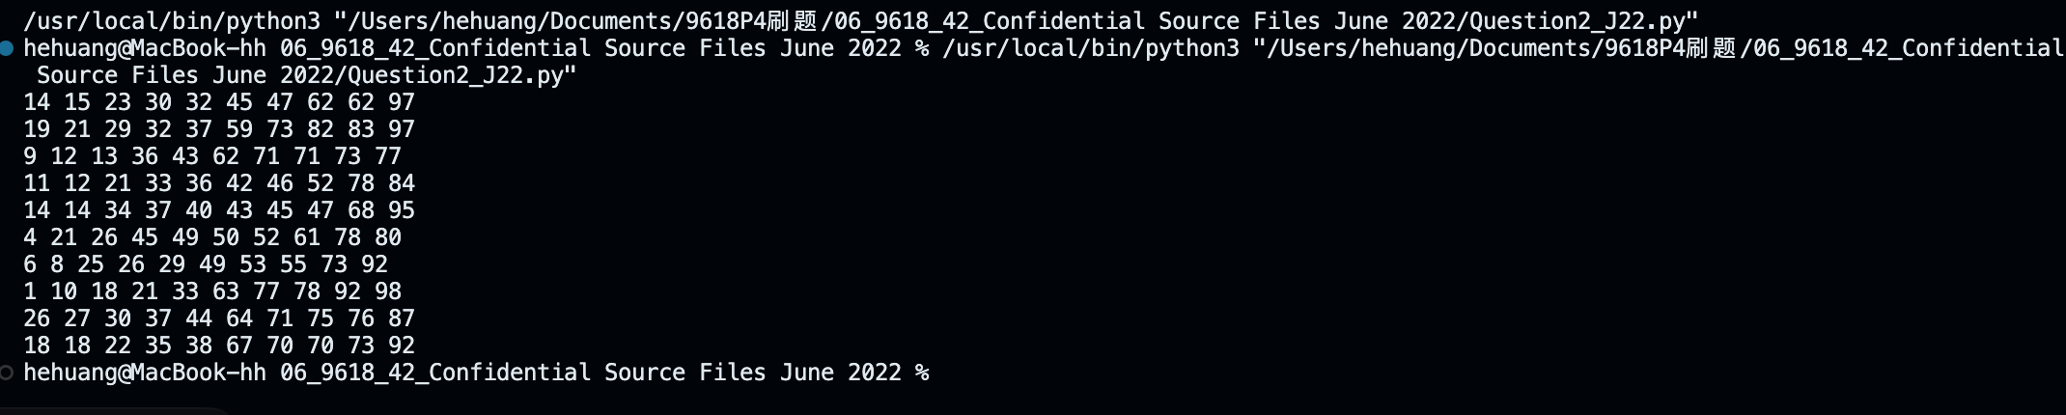

Part 2(c)(i)
{Copy and paste the program code listing for Question 2(c)(i) here}
def BinarySearch(SearchArray, Lower, Upper, SearchValue):

if Upper>=Lower:
Mid=(Lower+Upper)//2
if SearchArray[0][Mid] == SearchValue:
return Mid
else:
if SearchArray[0][Mid] > SearchValue:
return BinarySearch(SearchArray, Lower, Mid-1, SearchValue)
else:
return BinarySearch(SearchArray, Mid+1, Upper, SearchValue)

return -1

Part 2(c)(ii)
{Copy and paste the screenshot for Question 2(c)(ii) here}

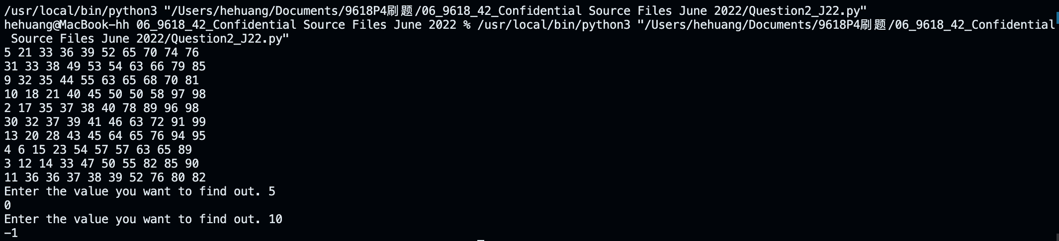

Question 3
Part 3(a)
{Copy and paste the program code listing for Question 3(a) here}

class Card:
def __init__(self,Num, CardColour):
self.__Number=Num # PRIVATE Number: INTEGER
self.__Colour=CardColour # PRIVATE Colour: STRING

Part 3(b)
{Copy and paste the program code listing for Question 3(b) here}

class Card:
def __init__(self,Num, CardColour):
self.__Number=Num # PRIVATE Number: INTEGER
self.__Colour=CardColour # PRIVATE Colour: STRING

def GetNumber(self):
return self.__Number
def GetColour(self):
return self.__Colour

Part 3(c)
{Copy and paste the program code listing for Question 3(c) here}

# main
ArrayCard=[Card(-1,"") for _ in range(30)] # DECLARE ArrayCard: ARRAY[1:30] OF Card
file=open("CardValues.txt", 'r')
count=0
for item in file:
if item != "":
Num=item
Colour=file.readline().strip()
ArrayCard[count]=Card(Num,Colour)
count+=1

Part 3(d)
{Copy and paste the program code listing for Question 3(d) here}

class Card:
def __init__(self,Num, CardColour):
self.__Number=Num # PRIVATE Number: INTEGER
self.__Colour=CardColour # PRIVATE Colour: STRING

def GetNumber(self):
return self.__Number
def GetColour(self):
return self.__Colour

def ChooseCard():
index=int(input("Enter a number between 1 and 30"))
if index>=1 and index <=30:
if CardSelection[index-1] is False:
CardSelection[index-1]=True
return index-1
else:
while CardSelection[index-1]:
index=int(input("Enter a number between 1 and 30"))
if index>=1 and index <=30:
if CardSelection[index-1] is False:
CardSelection[index-1]=True
return index-1

# main
ArrayCard=[Card(-1,"") for _ in range(30)] # DECLARE ArrayCard: ARRAY[1:30] OF Card
CardSelection=[False for _ in range(30)] # DECLARE CardSelection: ARRAY[1:30] OF BOOLEAN
file=open("CardValues.txt", 'r')
count=0
for item in file:
if item != "":
Num=item
Colour=file.readline().strip()
ArrayCard[count]=Card(Num,Colour)
count+=1

Part 3(e)(i)
{Copy and paste the program code listing for Question 3(e)(i) here}

# main
ArrayCard=[Card(-1,"") for _ in range(30)] # DECLARE ArrayCard: ARRAY[1:30] OF Card
CardSelection=[False for _ in range(30)] # DECLARE CardSelection: ARRAY[1:30] OF BOOLEAN
file=open("CardValues.txt", 'r')
count=0
for item in file:
if item != "":
Num=item
Colour=file.readline().strip()
ArrayCard[count]=Card(Num,Colour)
count+=1

Player1=[Card(-1,"") for _ in range(4)] # DECLARE Player1: ARRAY[1:4] OF Card

for j in range(4):
Player1[j]=ArrayCard[ChooseCard()]
for Cards in Player1:
print(f"Number: {str(Cards.GetNumber()).strip()}, Colour: {Cards.GetColour()}")

Part 3(e)(ii)
{Copy and paste the screenshot for Question 3(e)(ii) here}

